S4584569 Alev Akturk Tutorial 7

1. List contact name, address, city and country details of both customer and suppliers

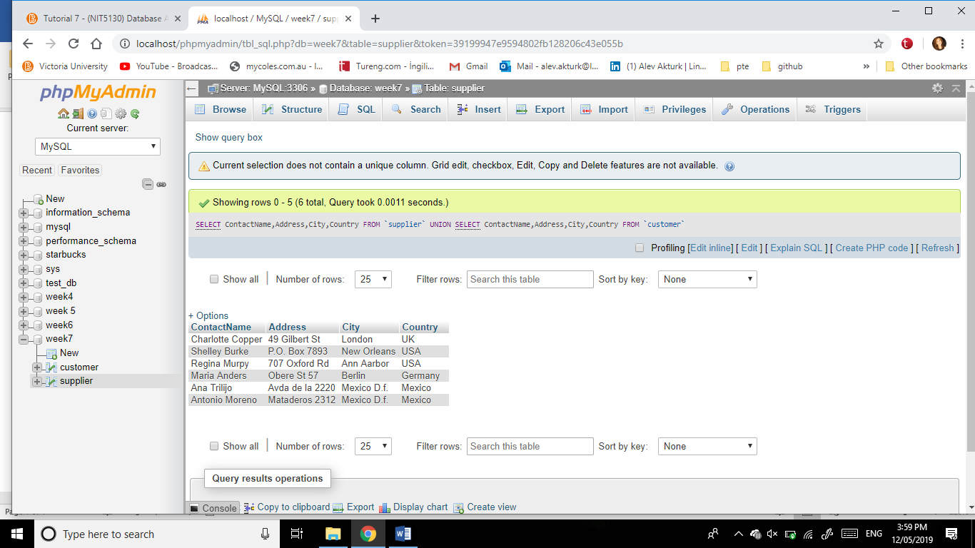[SELECT](http://localhost/phpmyadmin/url.php?url=https://dev.mysql.com/doc/refman/5.5/en/select.html) ContactName,Address,City,Country FROM `supplier` UNION [SELECT](http://localhost/phpmyadmin/url.php?url=https://dev.mysql.com/doc/refman/5.5/en/select.html) ContactName,Address,City,Country FROM `customer`

2) List the details of customer and suppliers.

SELECT * FROM `customer` UNION ALL SELECT * FROM `supplier`  
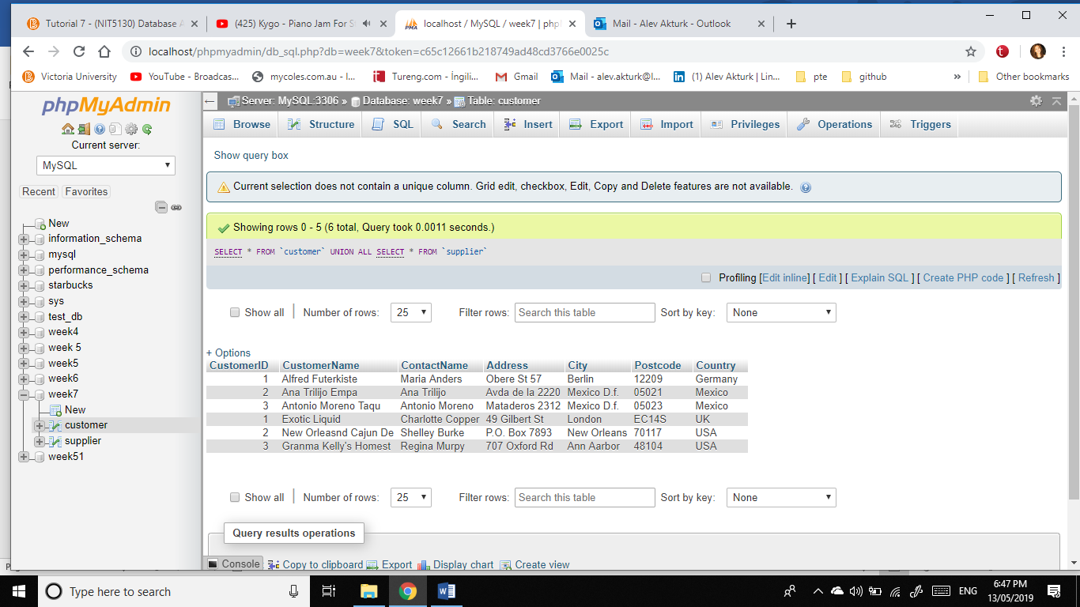

3) List name, address, city of customer and name, address, city of suppliers

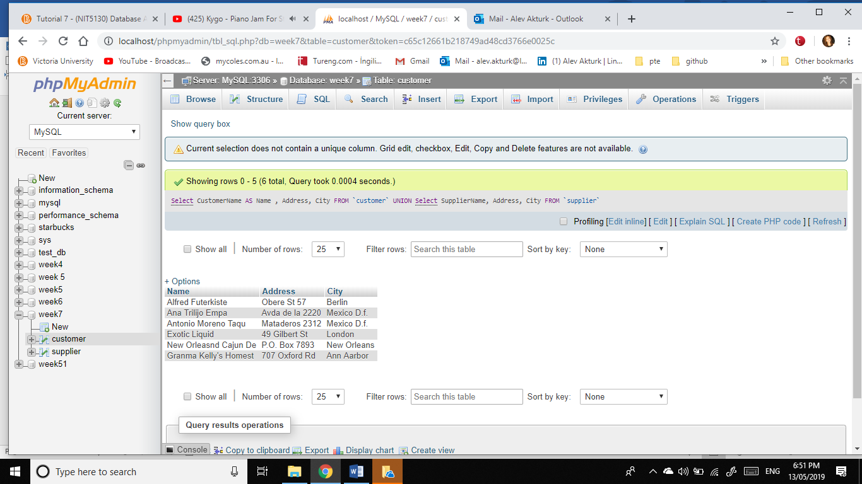[Select](http://localhost/phpmyadmin/url.php?url=https://dev.mysql.com/doc/refman/5.5/en/select.html) CustomerName AS Name , Address, City FROM `customer` UNION [Select](http://localhost/phpmyadmin/url.php?url=https://dev.mysql.com/doc/refman/5.5/en/select.html) SupplierName AS Name, Address, City FROM `supplier`

4. List name, address, city, country of suppliers and name, address, city of customer

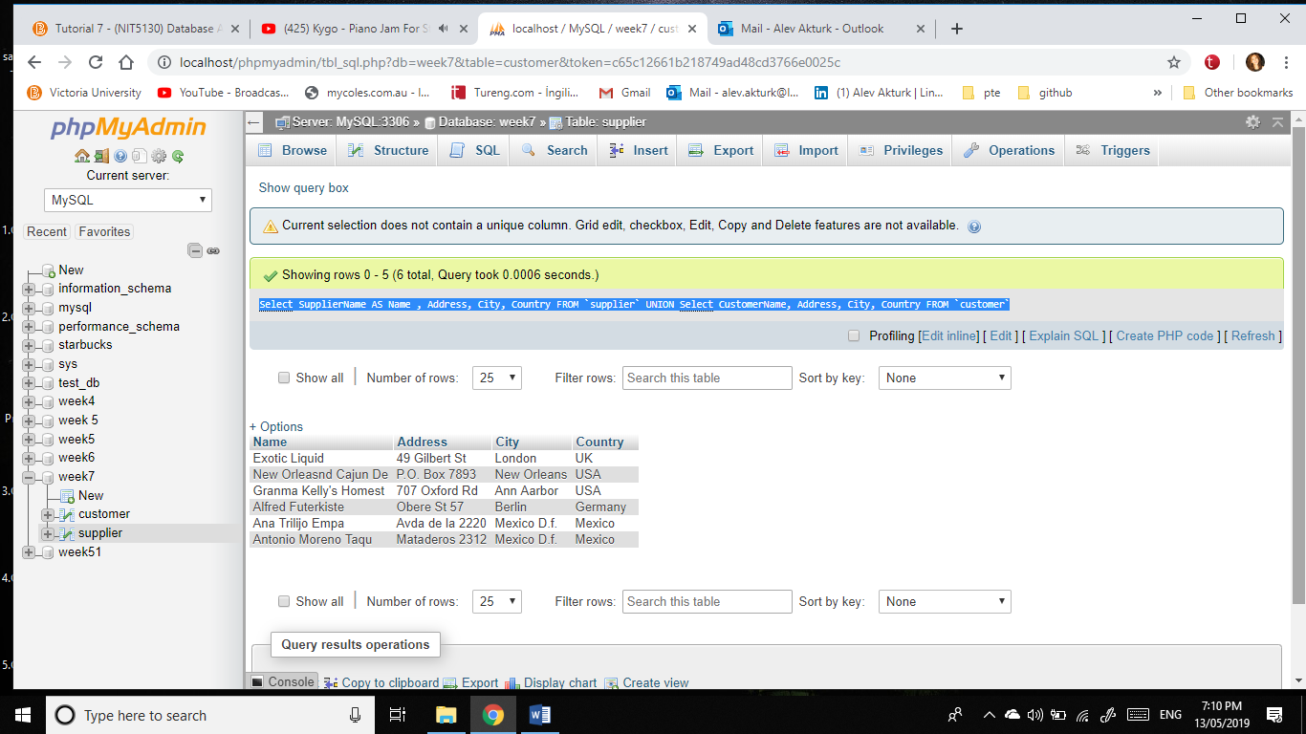[Select](http://localhost/phpmyadmin/url.php?url=https://dev.mysql.com/doc/refman/5.5/en/select.html) SupplierName AS Name , Address, City, Country FROM `supplier` UNION [Select](http://localhost/phpmyadmin/url.php?url=https://dev.mysql.com/doc/refman/5.5/en/select.html) CustomerName, Address, City, Country FROM `customer`

.